|  |
| --- |
| Date/Location |
| 02/22/2022 @Zoom |

|  |  |
| --- | --- |
| Attendees | |
| Client | MAVDEV |
| Joe Saceric | Ammar Lokhandwala |
| Umera Khan | Maria Frausto |
|  | Michael Gurch |
|  | Victoria Sheraden |
|  | Vivian Bui |

|  |
| --- |
| Meeting Agenda |

1. **Current Trello Board** (Please let us know if you have not yet received access to the board)

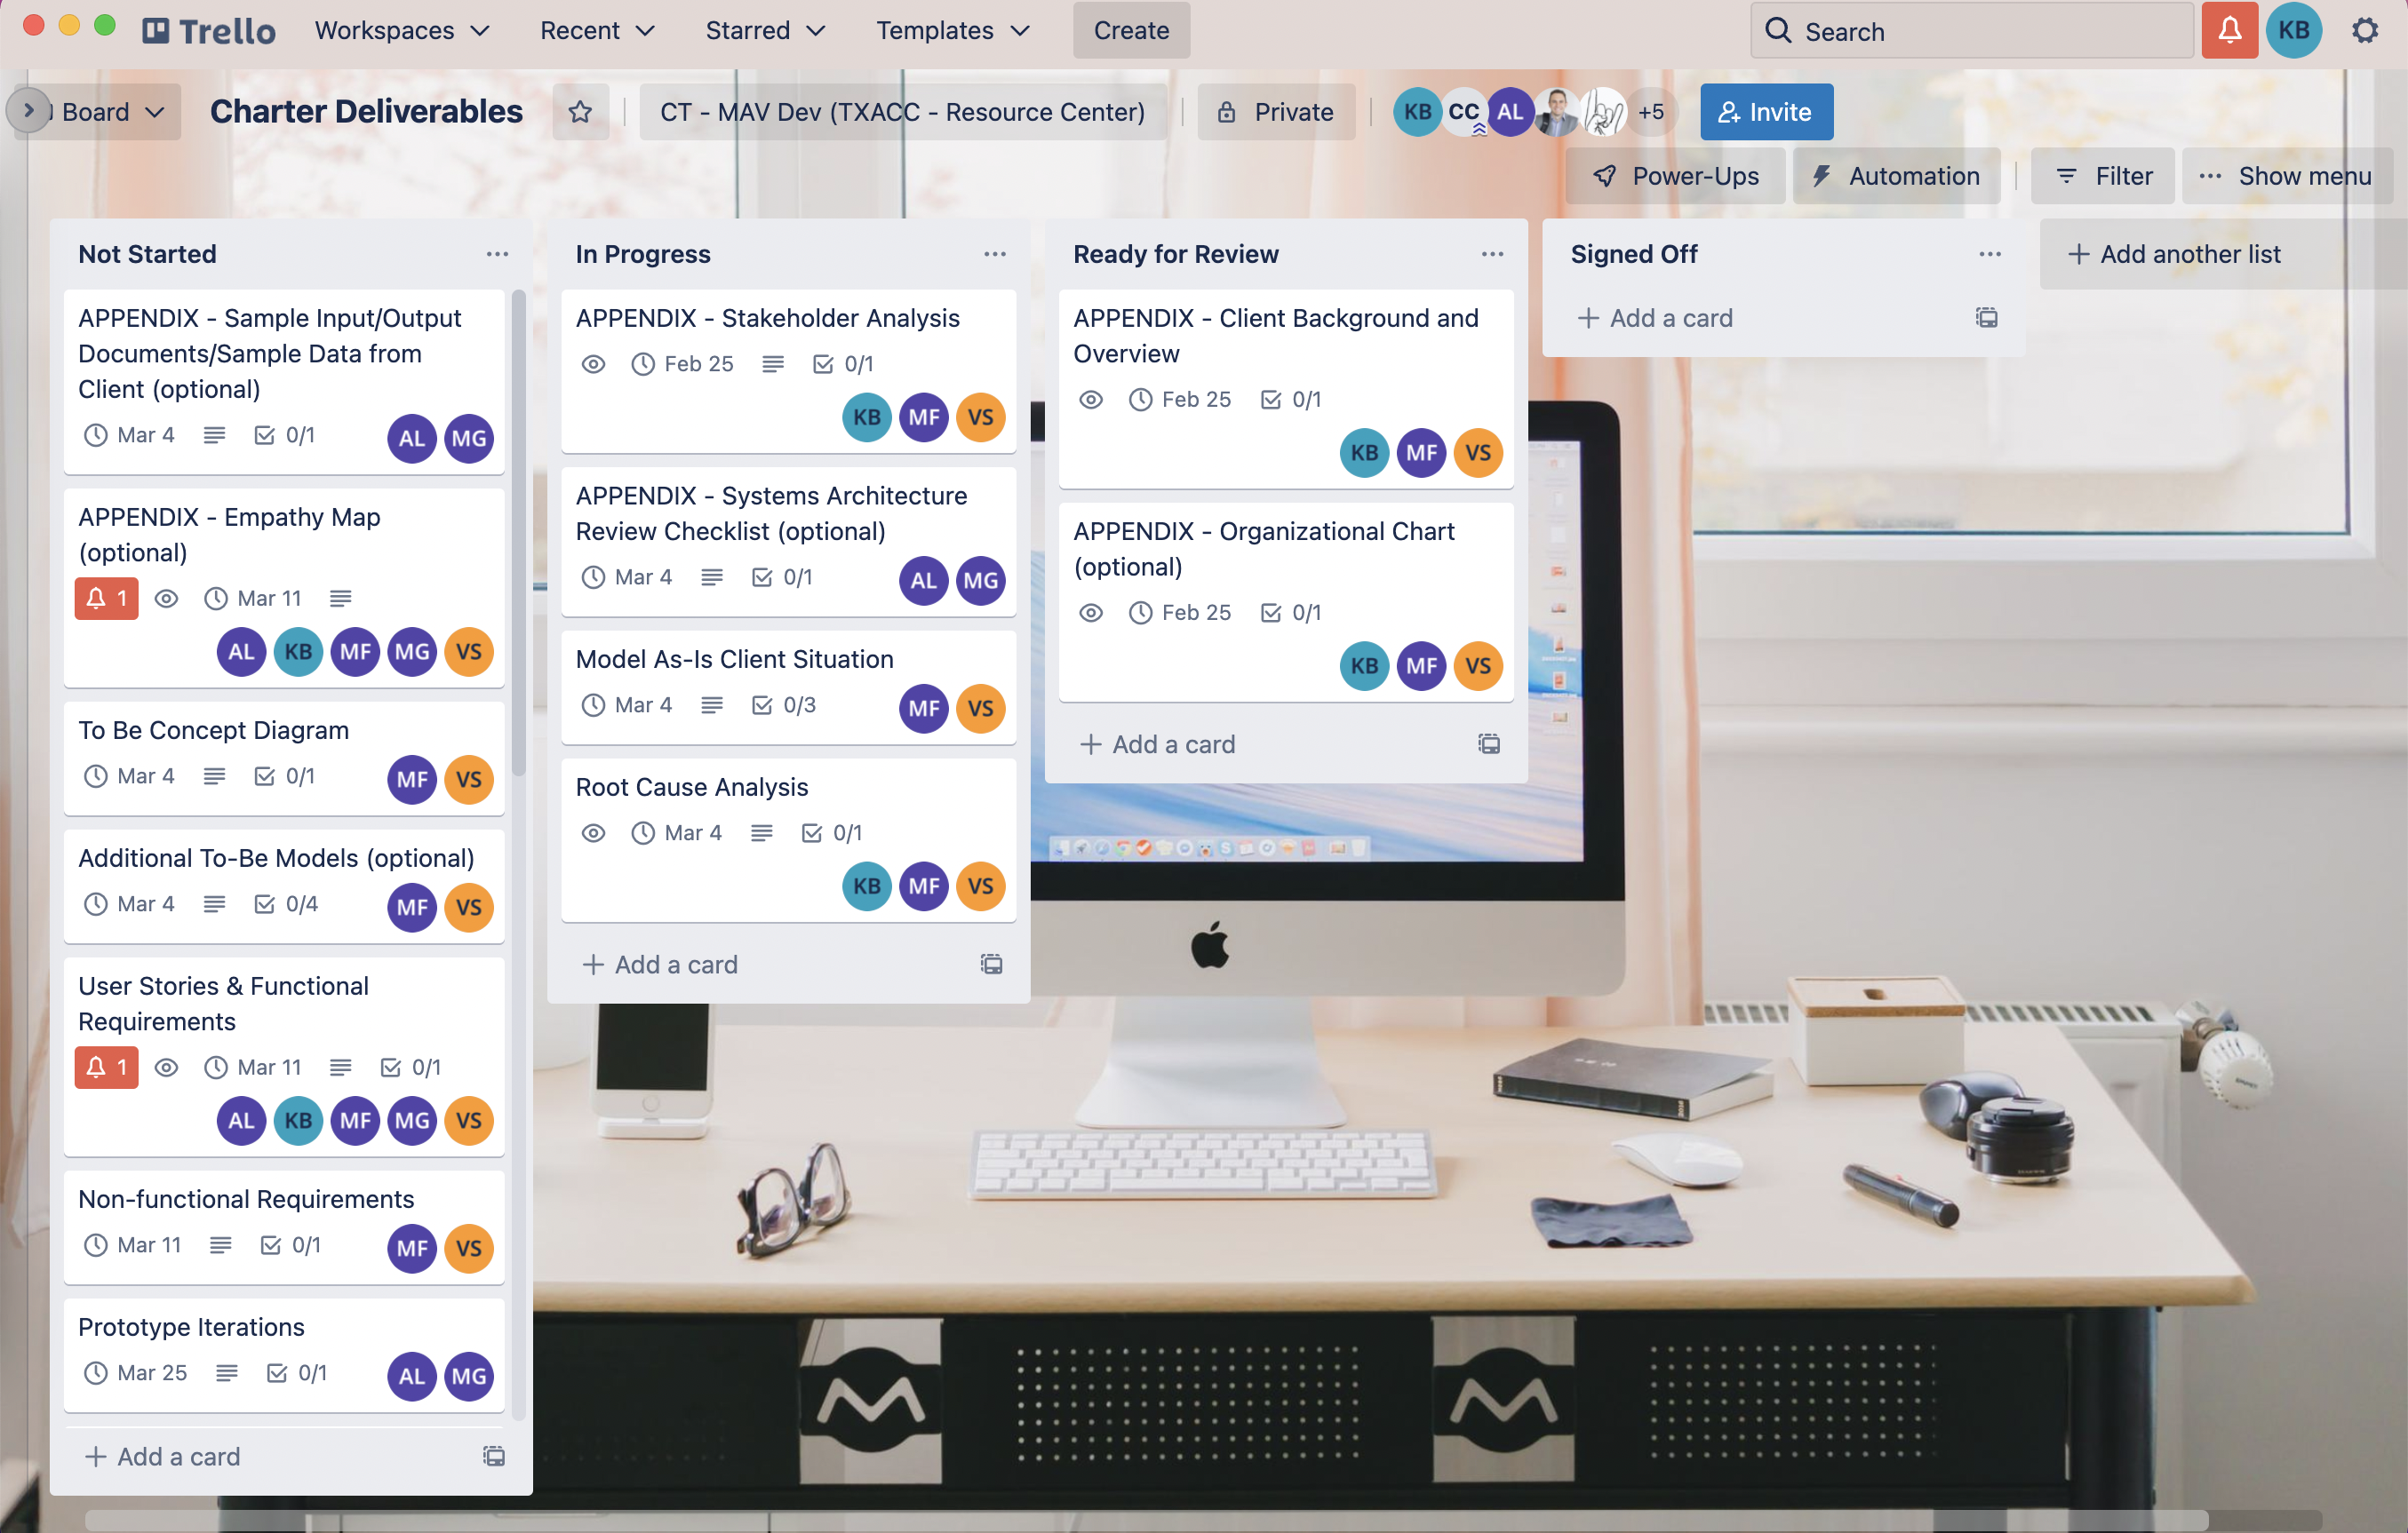

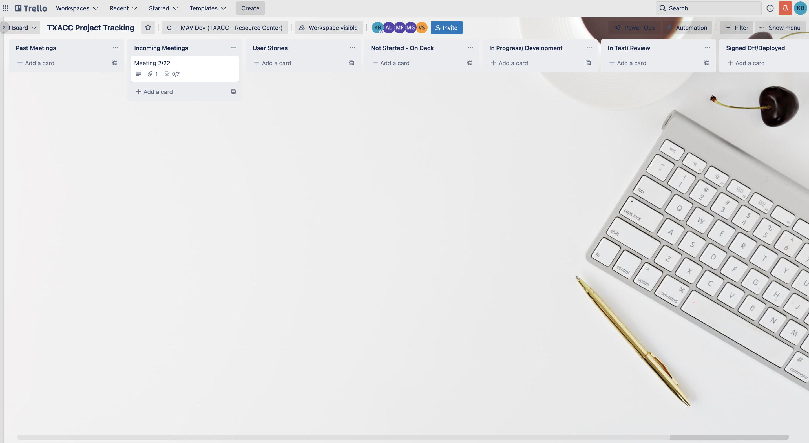

1. **Documents sent out (attached to Zoom Invitation):**

* Meeting slides
* Agenda Report (this document)
* Stakeholders List (Excel file)
* Link to Trello Board – TXACC Project Tracking

1. **Notes on Communication**
2. **Recurring Meeting:**

* We will have one to two recurring meetings per week
* Current time is set for 9:30 – 10:00 AM, Tuesday and Thursday. Potentially looking forward to changing to a 1-hour meeting instead of two 30-min meetings

1. **In-person meeting**

* MAVDEV is open to in-person meetings anytime since TXACC is near UT campus

1. **Point of contact**

Vivian Bui

346-332-6969

[vivianbui@utexas.edu](mailto:vivianbui@utexas.edu) | [vivianbui9889@gmail.com](mailto:vivianbui9889@gmail.com)

1. **Notes on Communication**

* Information about Meeting Agenda will be sent ***at least more than one day*** before each meeting, attached to the *Zoom invitation*
* Meeting Summary will be sent out at the end of every team meeting
* All Meeting Documents can be accessed at UT Box: <https://utexas.box.com/s/4fez1s09vf07lwzduc5pcevow0e7efz1>

1. **Project Tracking**

* Project Tracking (For Meetings and Development)

<https://trello.com/b/r8DXAHG0>

* For Charter Deliverables

<https://trello.com/b/sucG4Wpv>

1. **Next Meeting**

* Time: Thursday, 2/24 @9:30AM
* Location: Zoom

Meeting Agenda and Zoom Invitation will be sent out later tonight (2/22) between 9-10PM